1 b use case for school management system

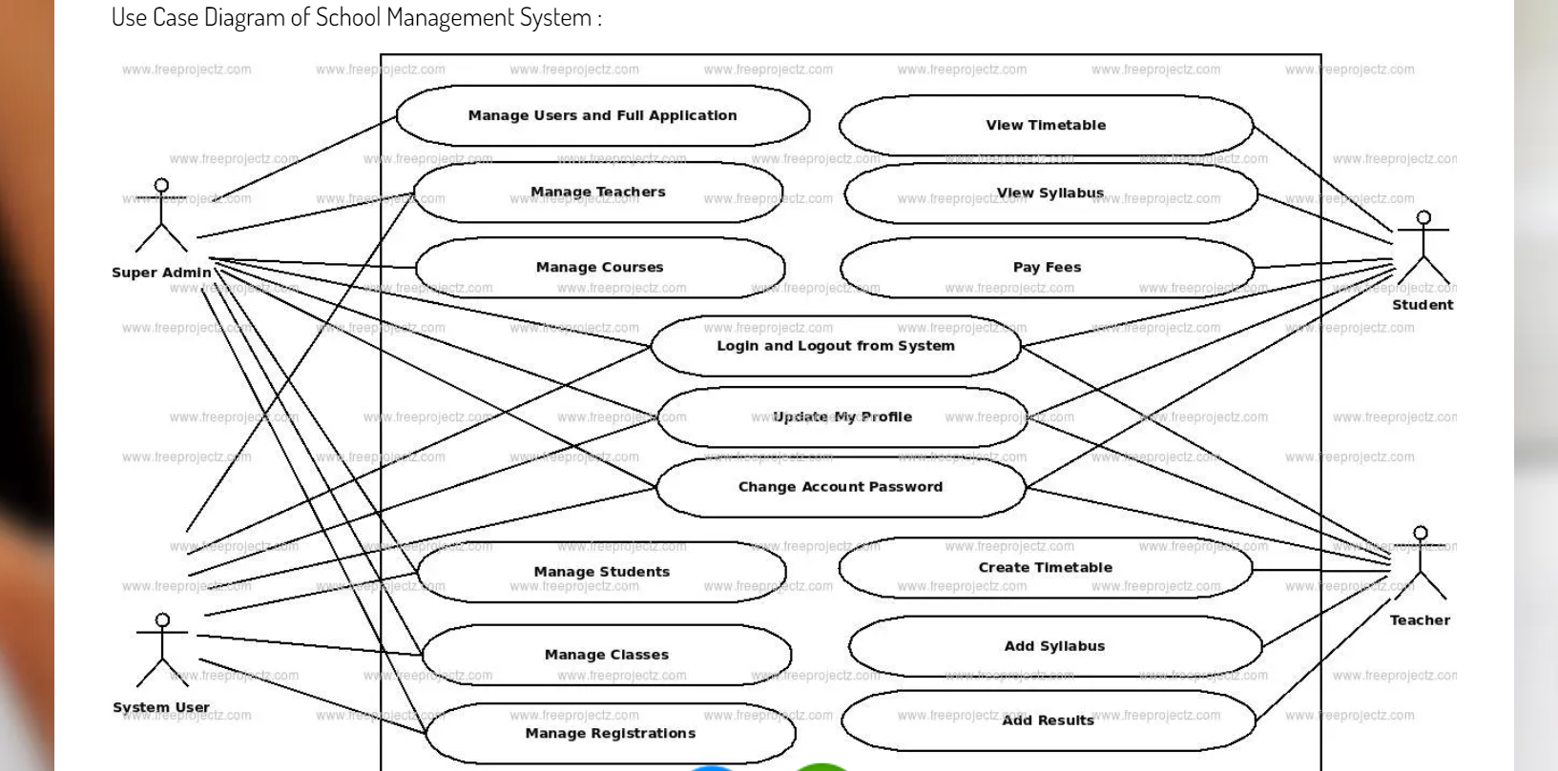

2 a dfd requirements of campus website

B sequence diagram for online shopping

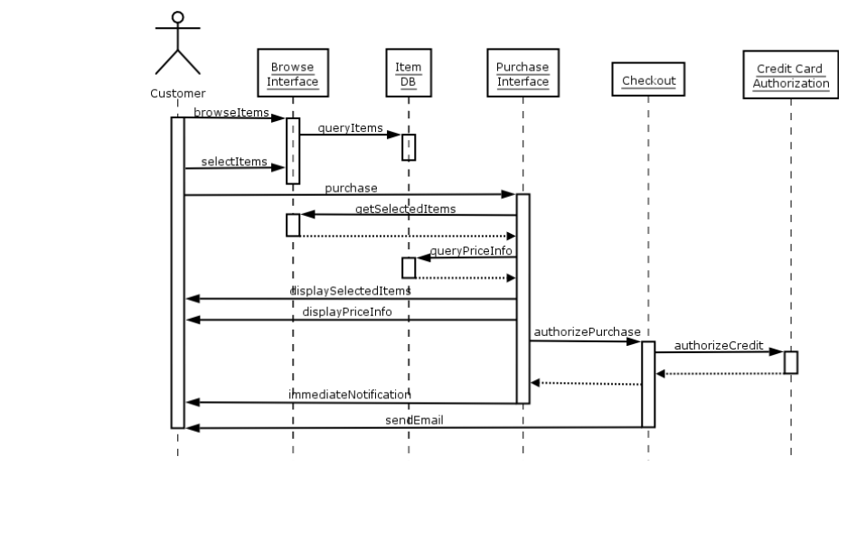

3 a fdd for library management

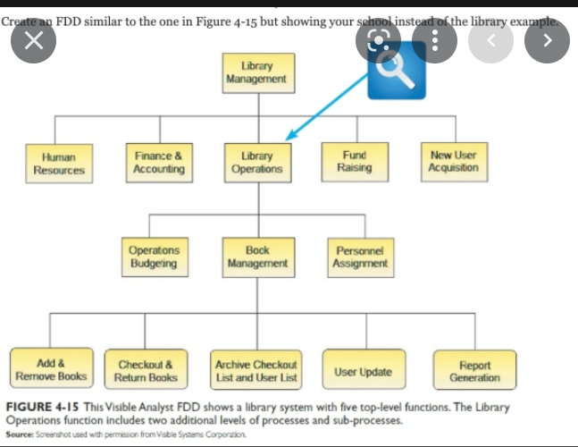

B collaboration diagram for atm machine

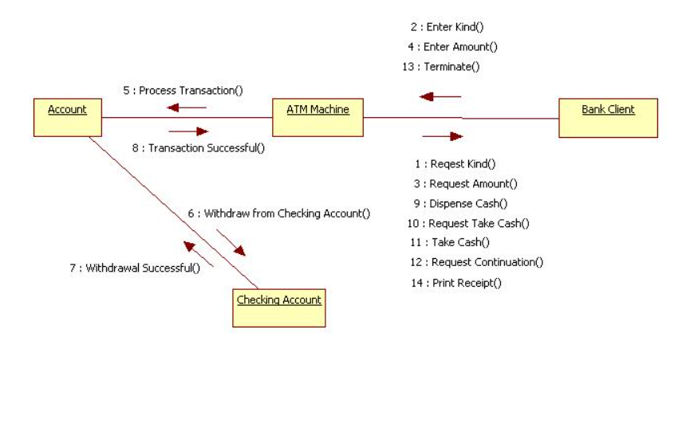

4 a use case of hotel management system

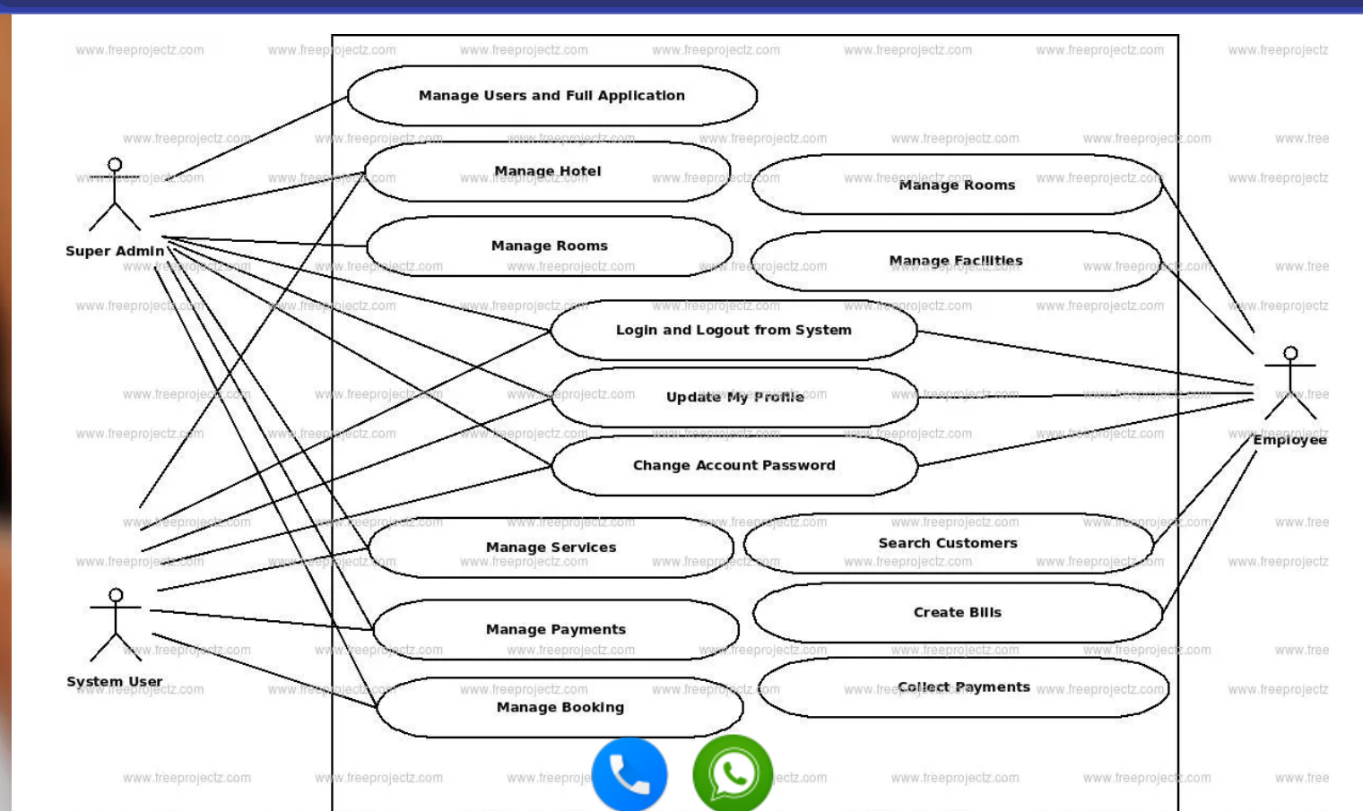

B dfd for ola application

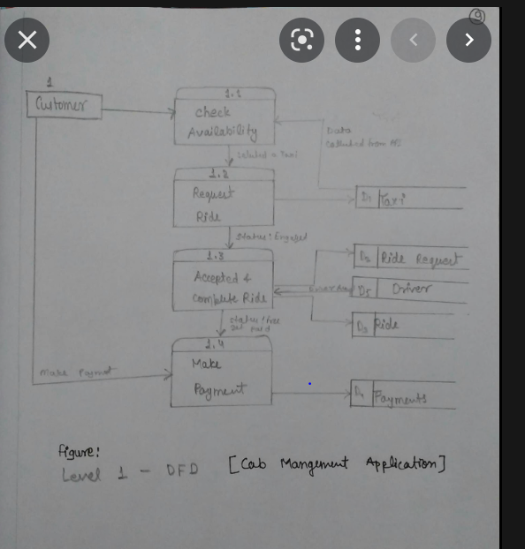

5 a sequence diagram for online food ordering system

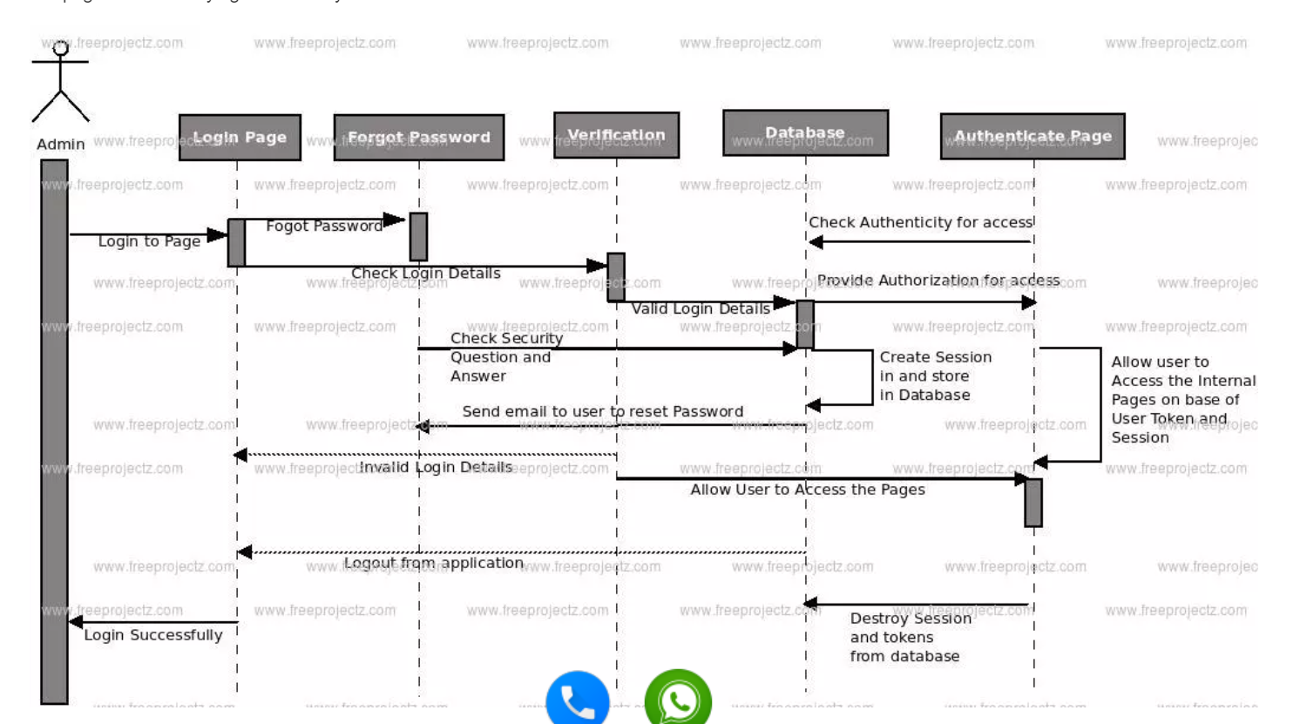

B fdd for online banking system

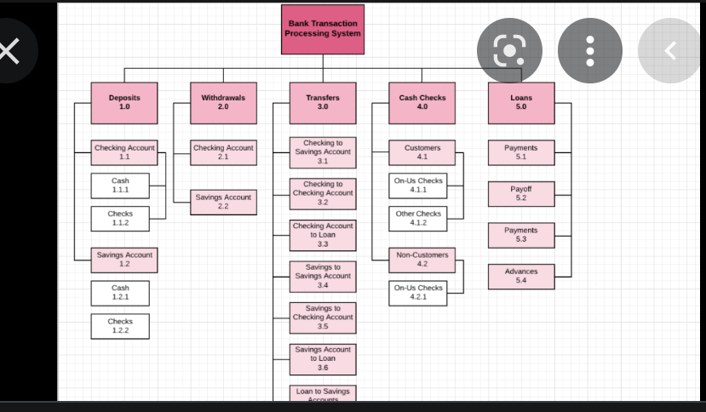

6 a collaboration digram for car pooling system

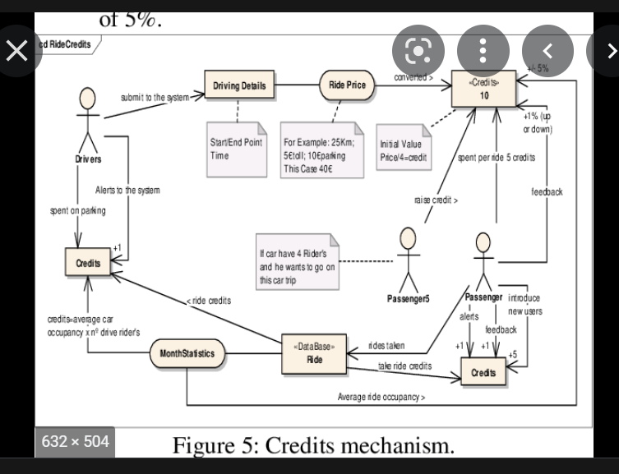

B class diagram for library management system’

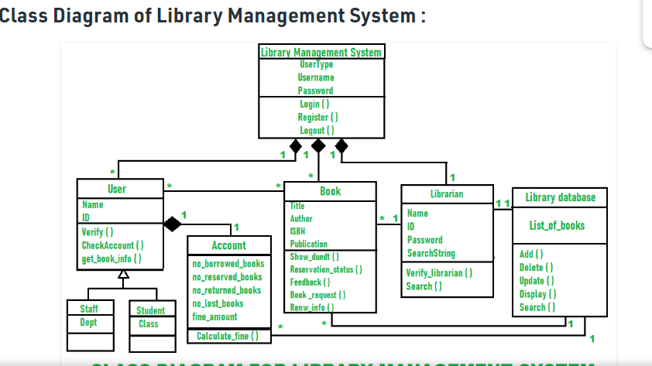

7 a state machine diagram for online banking system

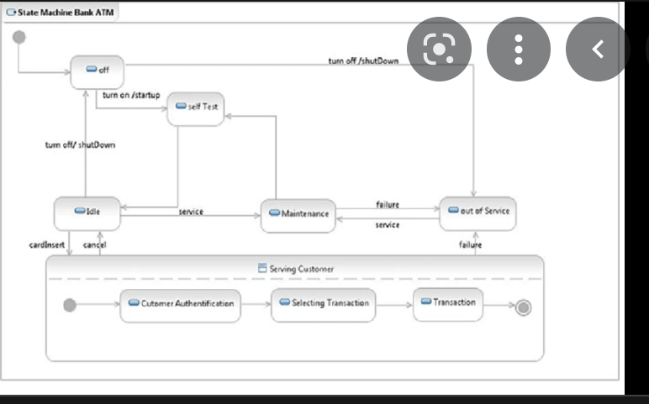

B use case for campus website

8 a class diagram for uber application

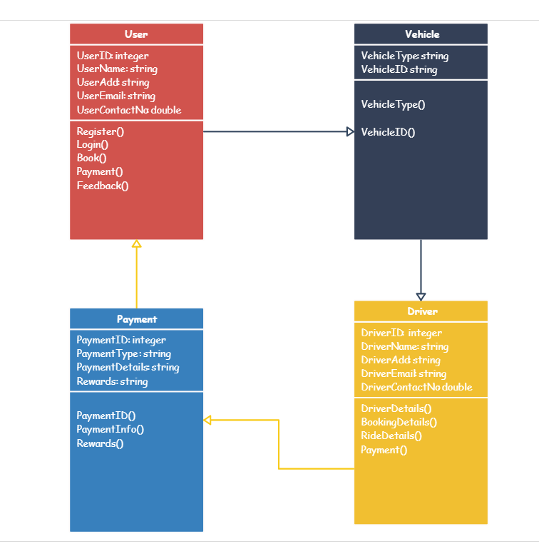

B fdd of hospital management system

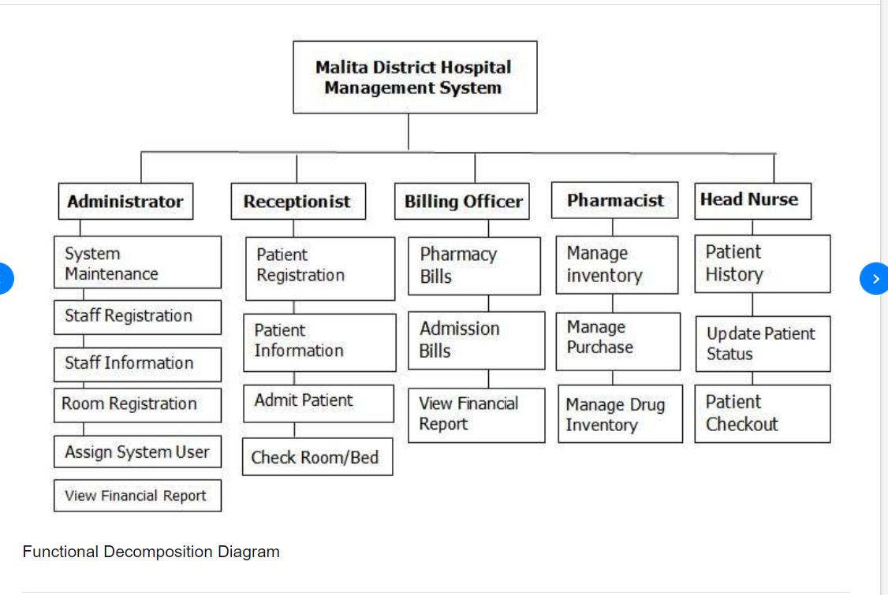

9 a use case diagram of atm machine

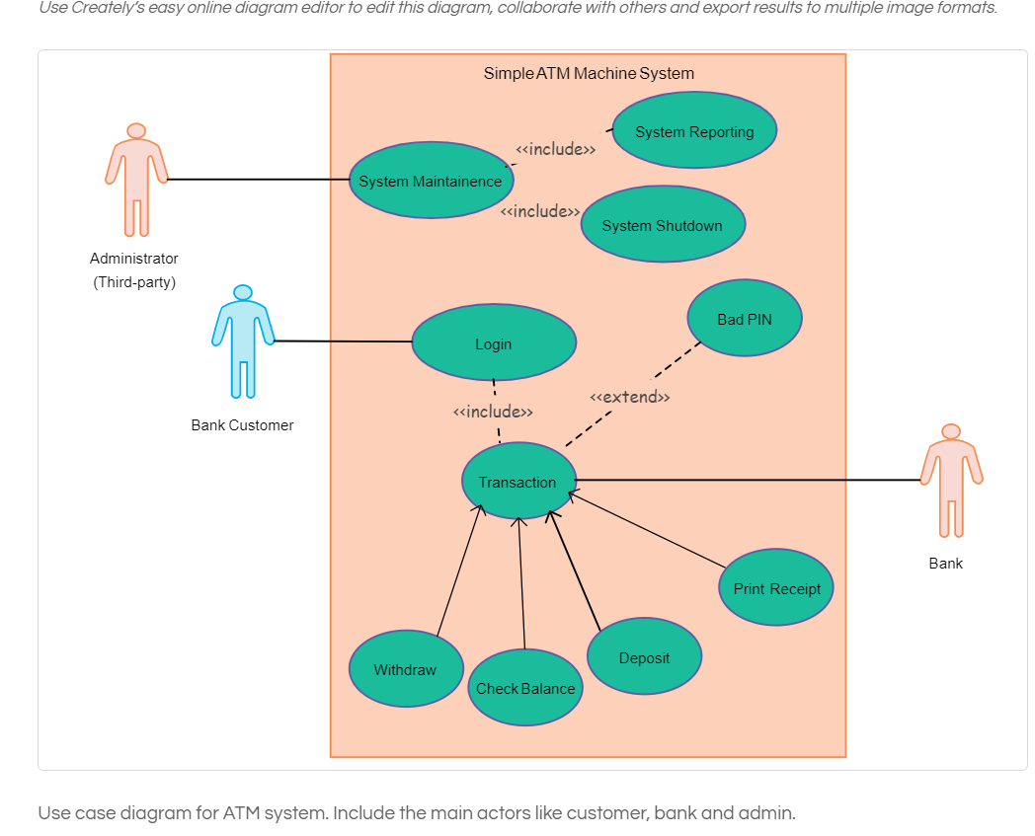

B Dfd for car pooling application

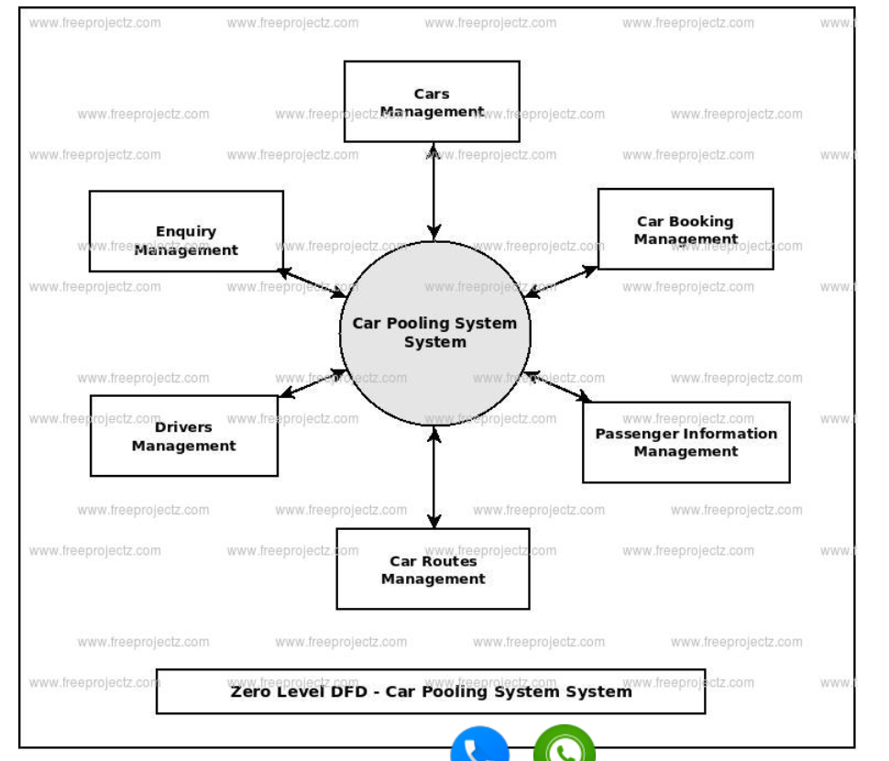

10 a class diagram of online shopping application

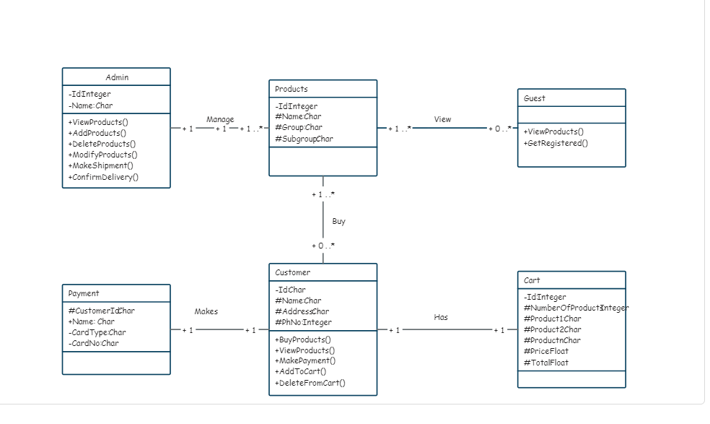

B collect software requirements and create srs for student information

11 a functional and non functional requirements of air line reservation system

B class diagram of atm

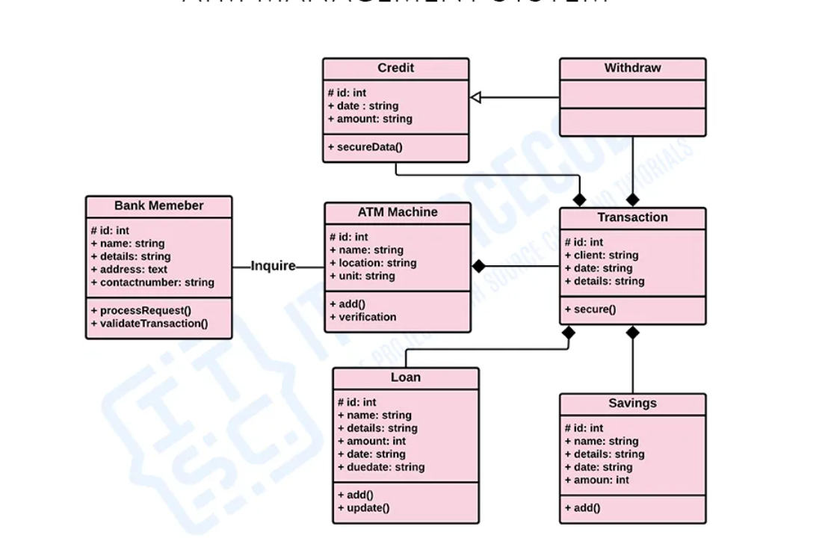

12 a dfd railway reservation system

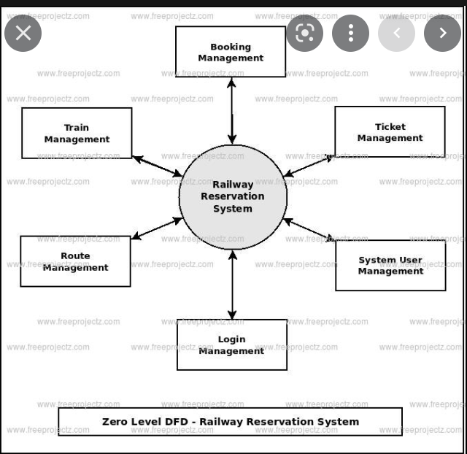

B state machine diagram for event management system

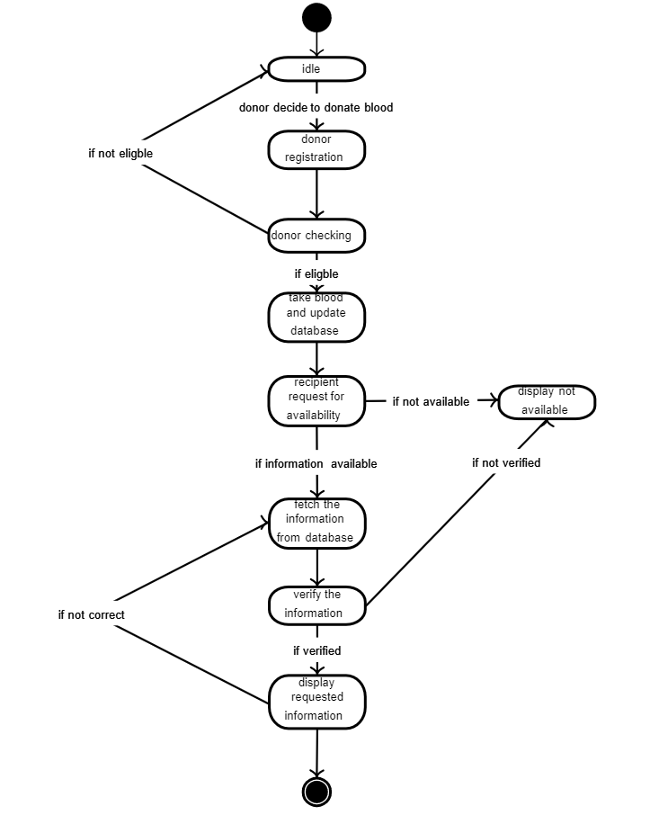

14 a class diagram of student monitoring system

B sequence diagram for red bus application

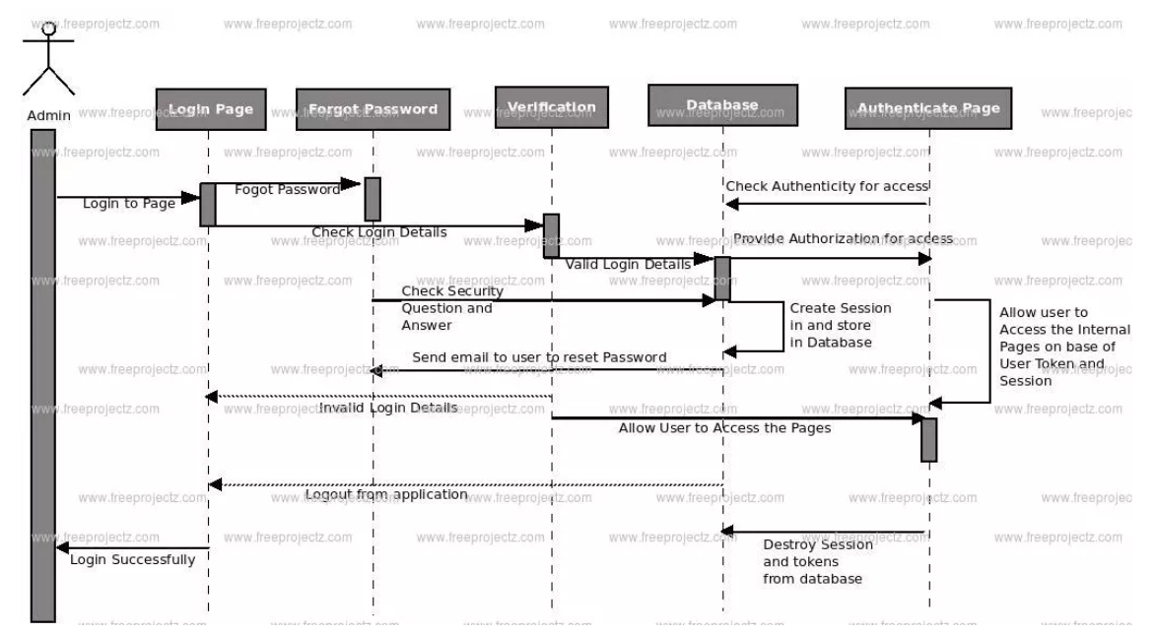

15 a use case diagram for online movie ticket booking

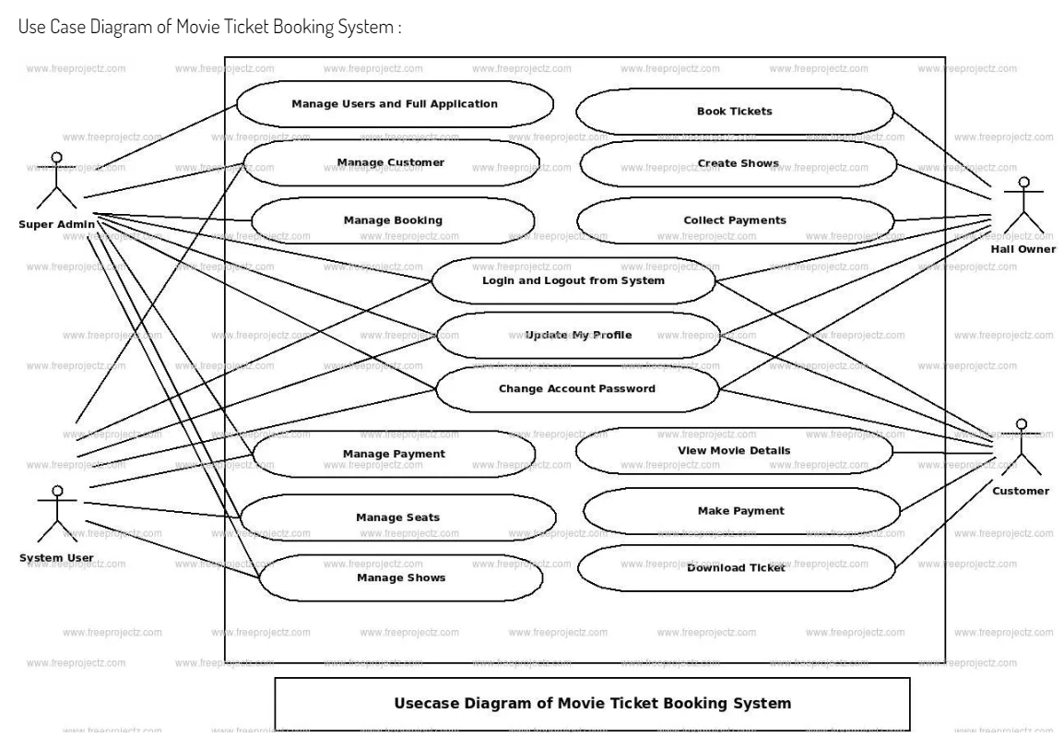

b state machine diagram for patient management system

